**ASSIGNMENT**

**(J Query Basic, Effects and Advanced)**

# 1) What is jQuery?

Ans: jQuery is a lightweight, JavaScript library. The purpose of jQuery is to make it much easier to use JavaScript on the website. jQuery takes a lot of common tasks that require many lines of JavaScript code to accomplish, and wraps them into methods that you can call with a single line of code. jQuery also simplifies a lot of the complicated things from JavaScript, like AJAX calls and DOM manipulation.

# 2) How to apply CSS Using jQuery, how to add class and remove class in jQuery, jQuery Animation?

Ans: The example of applying CSS using jQuery is shown below:

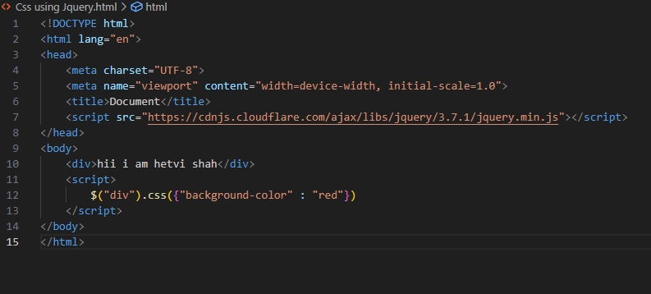

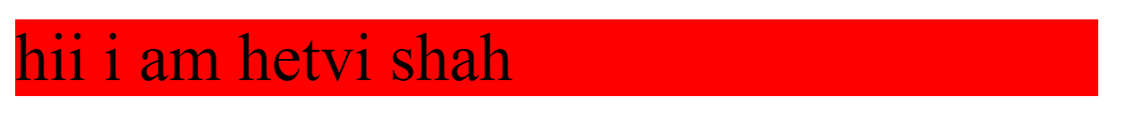

The class can be added by using addClass() function . The example is shown below:

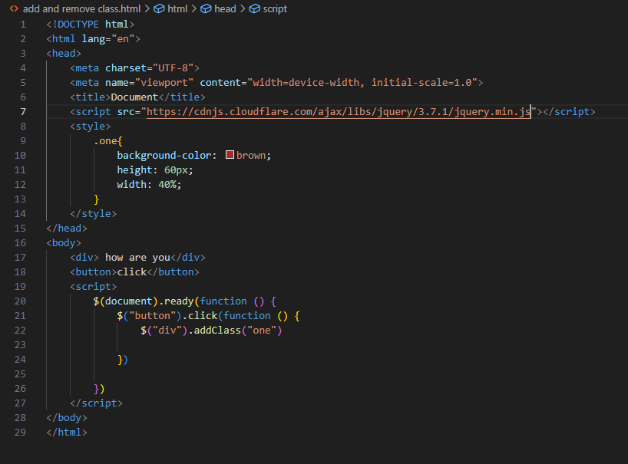

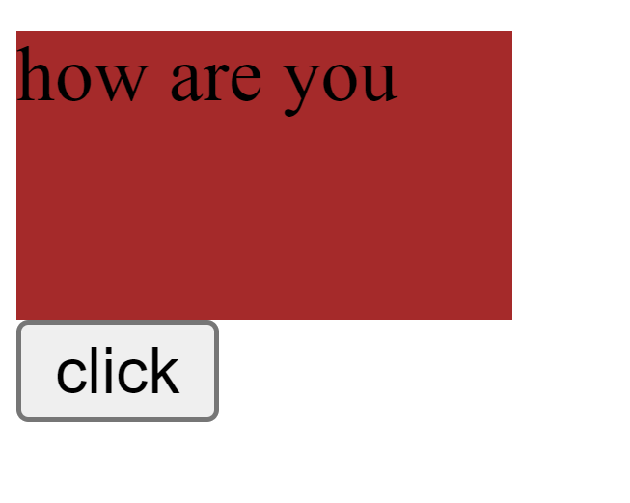

The class can be removed by using removeClass() function . The example is shown below:

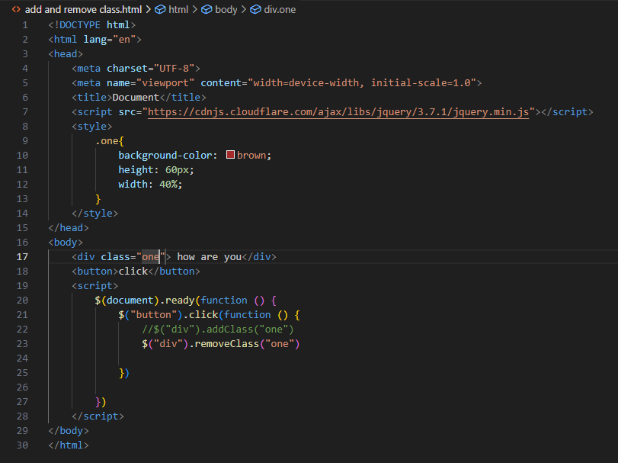

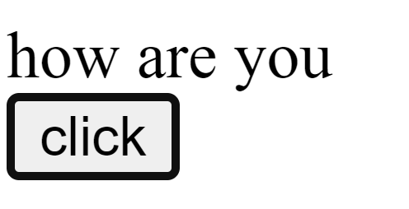

Animation can be done in jQuery using animate() function. The example of animation using jQuery is shown below:

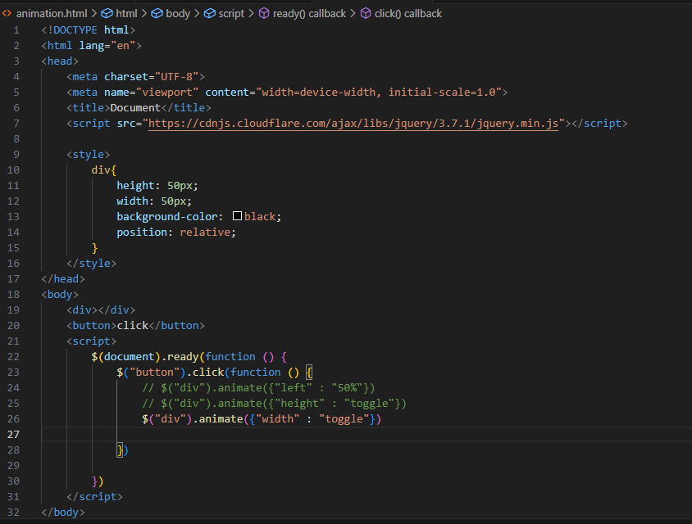

# 3) How to create slider with animation?

Ans: The slider can be created by using slideUp() and slideDown() function using jQuery . The example is shown below :-

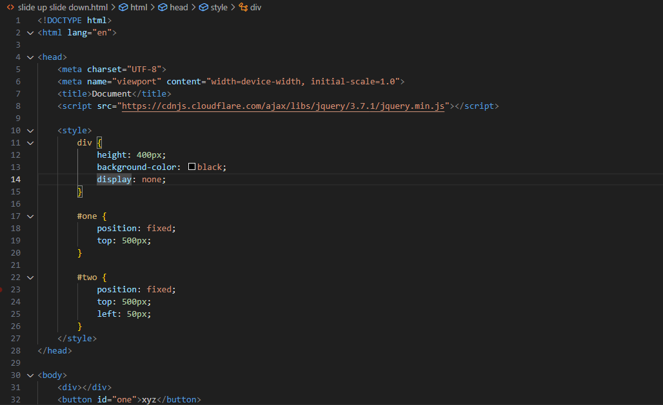

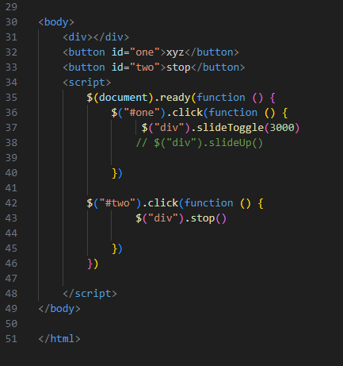

# 4) Event bubbling Tickling Example

